*Proposal for an*

**amberson pulse survey**

# summary of the proposal:

Develop, implement, and maintain at no cost to the Amberson Towers Condominium Association a process for an episodic online Amberson Pulse Survey of opinions of Amberson Towers owners/residents using Google Forms, Sheets, Charts, and Docs.

# need

Members of the Council for the Amberson Towers Condominium Association develop policies and practices consistent with the preferences of owners/residents of Amberson Towers. Owners/residents currently can communicate their preferences in periodic open forums, during Council meetings, and in conversations with Amberson Towers management and Council members.

The proposed Amberson Pulse Survey can provide opportunities for the Council to rapidly elicit and communicate opinions about policies and practices from all Internet-connected owners/residents. The Survey can fill the information gaps between occurrences of open forums and Council meetings and can offer more inclusive and organized intelligence than is possible in one-on-one discussions.

# responsibilities

The Technology Committee of the Amberson Towers Condominium Association will take responsibility for developing, implementing, and maintaining the Amberson Pulse Survey to fulfill the information needs of the Council. Anyone associated with Amberson Towers can suggest the opinions targeted by any Survey. However, the Technology Committee will coordinate the contents of any Survey with the Council, the primary audience for Survey findings. Initially, David Passmore (Unit 403), chair of the Technology Committee, will work closely with Gerry LaVan, President of the Council, to pilot test the Amberson Pulse Survey.

# process

To review the process for the Survey, view the flowchart, *Process for Amberson Towers Pulse Survey*. The remainder of this proposal describes the ten elements in the process flowchart. The process could occur over four days (say, Thursday through Sunday), with reporting of findings on the fifth day (say. Monday).

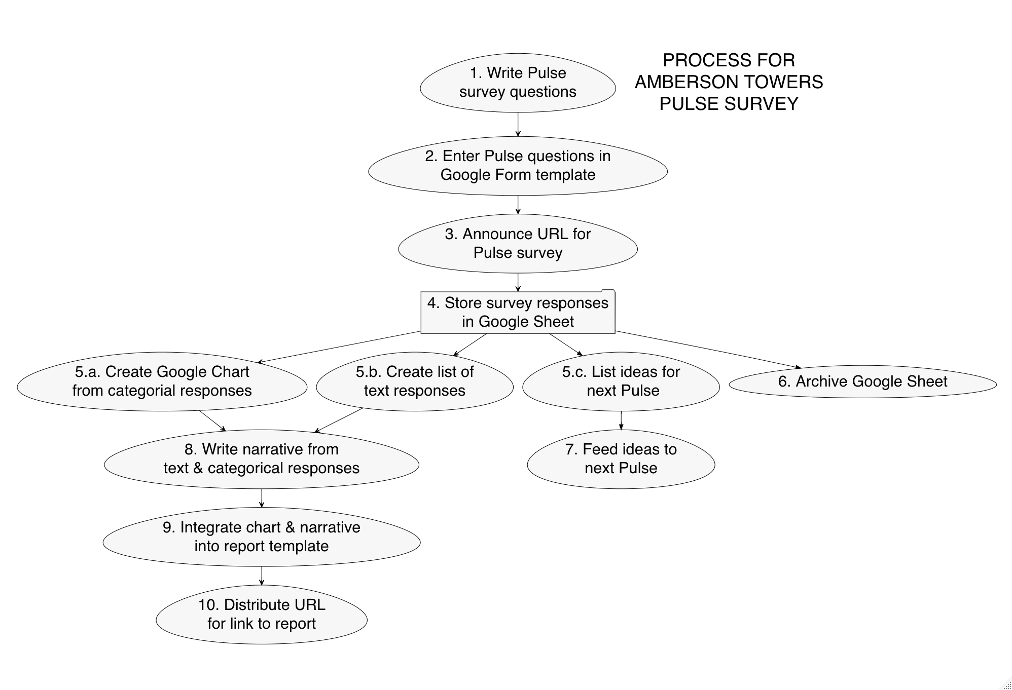

View a mock-up of an Amberson Pulse Survey at https://bit.ly/AmbersonPulse. The mock-up is a Google Form. Here is a snapshot of the top of the mock-up:

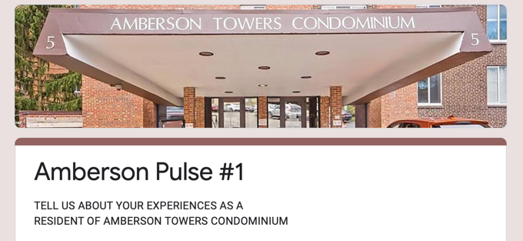

I present details about each of the ten steps numbered in the flowchart, *Process for Amberson Towers Pulse Survey*:

j *Write questions*. A pulse survey should include ONE question focused on a specific policy or practice. Many formats are available for categorical response alternatives, which should be clear, specific, and mutually exclusive. Another question should allow a free-form text response to the question. Background information should detail the topic under consideration. Then, elicited in a final question are topics for a future Amberson Pulse Survey. From the mock-up:

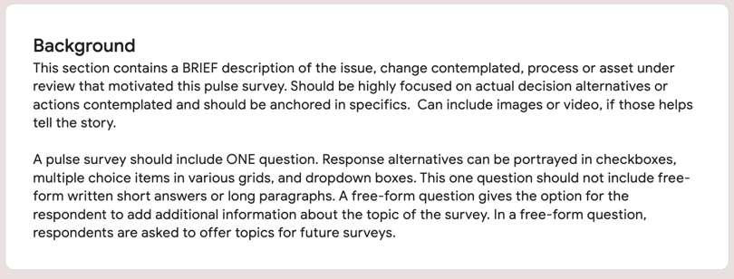

k *Enter questions*. The mock-up of an Amberson Pulse Survey at https://bit.ly/AmbersonPulse is a template that allows easy revision with future Survey questions. Only designated Survey editors may revise the Survey. A prepared Survey is accessible to any online user without Google or any other authentication.

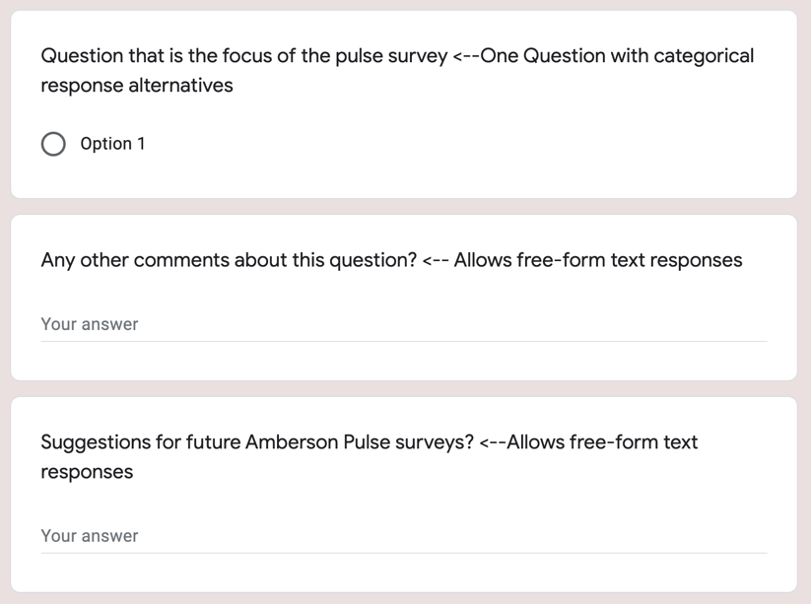

l *Announce URL*. The URL for an Amberson Pulse Survey is distributed through the ambersontowers.org email list. The long Google-provided URL for the Survey is shortened using a free tool available at https://bit.ly. Some owners/residents who have chosen not to receive online information about Amberson Towers Condominium will not have access to the Survey. However, unconnected owners/residents still may communicate their opinions and preferences through periodic open forums, during Council meetings, and in conversations with Amberson Towers management and Council members.

m *Store responses*. A Google Sheet linked directly to the Google Form stores responses to questions.

n (a) *Create Google Chart.* A simple visualization of categorical responses to the main Survey question is created through Google Chart, which is linked to the Google Sheet containing Survey responses. Likely visualizations are horizontal or vertical bar charts.

(b) *List text responses*. Text responses from the Survey are listed. Off-topic and abusive text responses are deleted. Any personally identifying information in responses is deleted. Errors in spelling and grammar are corrected.

(c) *List text responses*. Suggestions for future surveys are summarized.

o *Archive data.* The Google Sheet containing the Survey responses is duplicated and stored in another GitHub repository used to archive Amberson Towers Condominium documents.

p *Ideas for new Survey.* Suggestions for new Survey topics are listed and shared with Council and Technology Committee members.

q *Write narrative.* A draft is prepared of a succinct, factual narrative report about Survey findings and is shared with a member of the Council or the Technology Committee for feedback.

r *Integrate into a template.* The reviewed and edited narrative of the Survey findings is merged into a one-page infographic.

s *Distribute.* A bit.ly-created URL pointing to the one-page infographic is listed on the Ambersontowers.org website, is distributed to owners/residents subscribed to the ambersontowers.org email distribution list, and is posted on bulletin boards in the building.